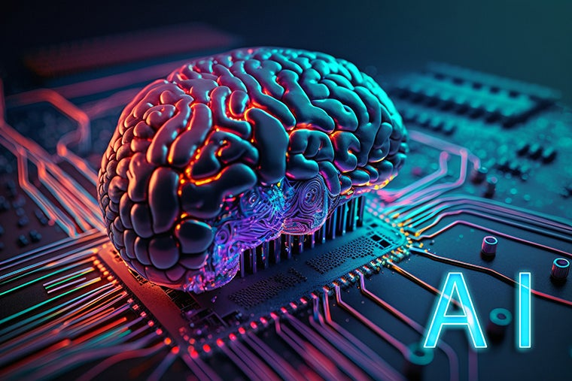

Artificial Intelligence (AI) is a transformative technology that enables computers and machines to simulate human intelligence, reasoning, learning, and problem-solving. In the modern digital landscape, it serves as the ultimate creative partner and productivity engine. It enables Machines to think without any human intervention.

Attention Is All You Need

Artificial intelligence (AI) is the simulation of human brain (highly inspired or simplified way, rather than being an exact) by computer systems. These systems are designed to perform complex tasks that typically require human intelligence, such as learning, reasoning, problem-solving, understanding language, and recognizing patterns. It can perform physical work as robot.
Uder AI, we have Machine learning, Deep learning, Large Language Model, Gen AI and NLP.
Machine Learning is a subset of Artificial Intelligence. ML is the study of computer algorithms that improve automatically through experience. ML explores the study and construction of algorithms that can learn from data and make predictions on data. Based on more data, machine learning can change actions and responses which will make it more efficient, adaptable, and scalable.
Deep Learning is a technique for implementing machine learning algorithms. It uses Artificial Neural Networks for training data to achieve highly promising decision making. The neural network performs micro calculations with computational on many layers and can handle tasks like humans.
Large Language Models (LLMs) are built on the Transformer architecture based on self-attention mechanism it simulates human intelligence. LLM process information using a Transformer architecture, which reads all words in a sentence at the same time to understand context. Instead of reading word-by-word from left to right, it analyzes how every word relates to every other word simultaneously. Below is the step-by-step breakdown of how architecture processes your text:
Tokenization: I break your text into smaller pieces called tokens, which can be whole words or syllables.
Embeddings: I convert these tokens into long lists of numbers (vectors) that capture the meaning of the words.
Positional Encoding: I add mathematical tags to these numbers so I know the exact order of the words in the sentence.
Self-Attention: I calculate mathematical weights to see which words depend on each other, allowing me to understand pronouns like "it" or "they."
Multi-Head Attention: I run this attention calculation multiple times at once to spot different relationships, like grammar rules and emotional tone.
Feed-Forward Network: I pass the processed data through dense layers of mathematical formulas to refine the information.
Output Generation: I calculate the probability of the next best token and output it, repeating the cycle until the response is finished.
Self-attention mechanism is the core engine of Transformer models. It enables a model to process every word in a sequence simultaneously and determine which words are most relevant to each other, allowing it to capture the deep, dynamic context of a sentence
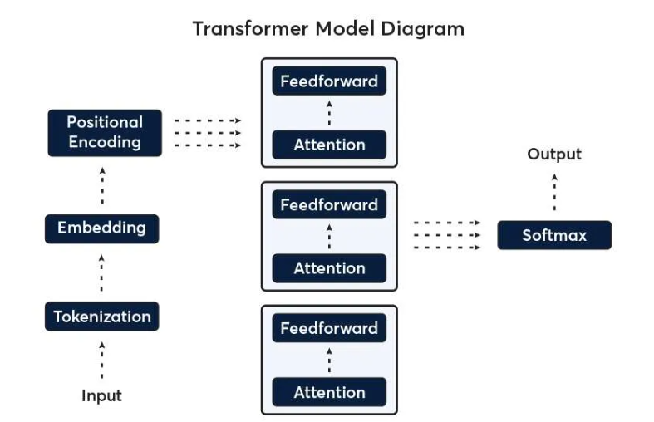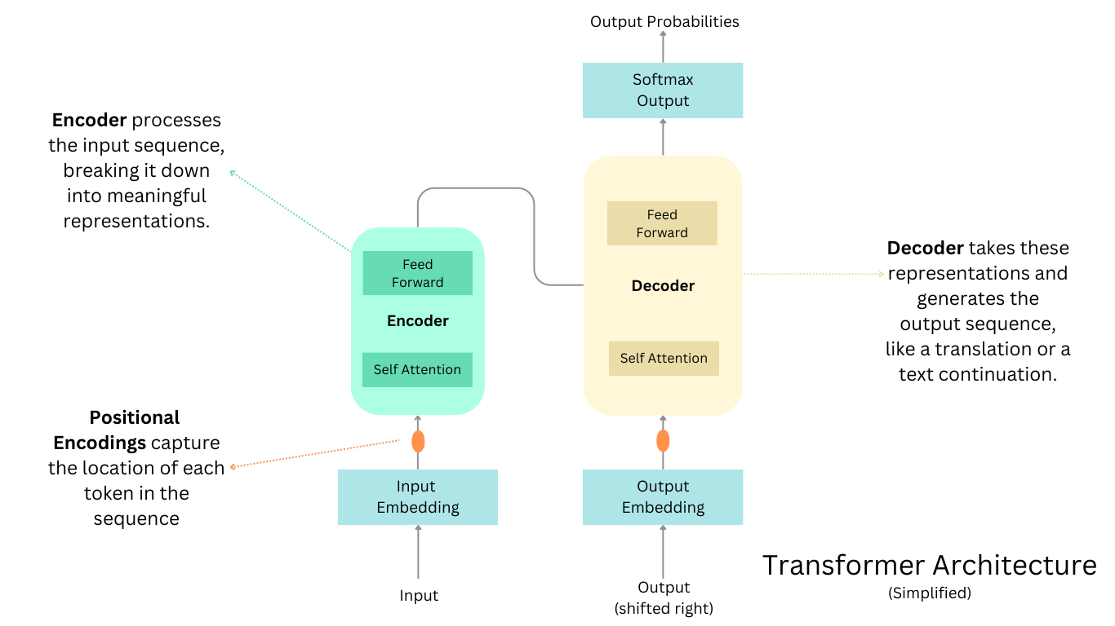

Generative AI(GenAI): GenAI is the broad umbrella term for any AI that creates new content. It is a type of AI focused on creating content like text, images, and audio by recognizing and replicating learned patterns in data. All LLMs are GenAI, but not all GenAI are LLMs
Natural Language Processing (NLP): The technology that enables machines to understand, interpret, and generate human language
Additional reference:
Data science is the study of data used to extract meaningful insights for business decisions. It combines mathematics, computing and domain knowledge to solve real-world problems and uncover hidden patterns. It processes raw data to address business challenges and predict future trends.
Algorithm is a step-by-step procedure used to analyze data, while Model is the learned output generated after that algorithm runs on a training dataset.

Algorithm | Where it is used (use case) | Type of learning | Math behind it (Sample)
Linear Regression | House/Car Prediction | Supervised (Regression) | Straight line equation, least squares
Logistic Regression | Spam detection, disease Yes/No | Supervised (Classification) | Sigmoid function, probability, log loss
Decision Tree | Credit approval, rules-based systems | Supervised | If-else rules, entropy, information gain
Random forest | Croud detection, churn prediction | Supervised | Multiple decision trees and averaging(statistics)
Support vector machine (SVM) | Text classification, face recognition | Supervised | Geometry, Maximum margin, vectors
K nearest Neighbors (KNN) | Recommendation, patten machine | Supervised | Distance calculation (Euclidean)
Naïve Bayes | Email spam filtering, NLP | Supervised | Bayes theorem, probability
K-Means | Customer segmentation | Unsupervised | Distance minimization, centroids
Hierarchical clustering | Market research | Unsupervised | Distance linkage, tree structure
PAC | Feature reduction, Visualization | Unsupervised | Linear algebra , eigenvector
Neural Network (ANN) | Image, Speech prediction | Supervised | Weighted sums, gradients ,calculas
Deep Learning Model
Algorithm | Full Form | Best For | Example | Analogy
RNN | Recurrent Neural Network | Sequential data | Text, Speech, time series forecasting | Reading a sentence word by word
CNN | Convolutional Neural Network
ANN | Artificial Neural Network | Tabular or Structured data | Predicting credit score, stock trends | A student solving math problems using rules learned
LLM Model
Algorithm | Example | Best For | Example | Analogy
Transformer | GPT, Gemini | All | GenAI

